

**Rules**

* A signed slip from leaders needs to be given into to registration to confirm a place.
* Members of the participating team must registar ( No leaders )
* No cheating
* The teams need to consist of both males and females
* Listen to all networker/ Adults at all times
* Teamwork is mandatory with participants assisting each other at all time.
* No swapping players throughout the event
* No white or transparent clothing and wear appropriate footwear and take care at all times
* Be respectful to all networkers/leaders running the event.
* (Spectators) all individuals that enter the supermooter zone e.g participants and spectators have to get involved in the activity and that therefore will get wet and muddy.
* Please be aware that all posts, photos, and videos are shared on the Mersey moot website and facebook page. Due to the large number of participants , it will be extremely difficult to avoid capturing participants with no photo permission, please consider this when selecting participants for this activity.
* Due to limited spaces, not all teams may be allocated a place at the event. To ensure fair representation across the county and wider regions, places will be distributed with consideration to district balance. This means some units may not be successful in securing a space.

**Scoring method**

The supermooter is scored using a points system, the team at the end with the most points, wins.

* **5 points** if the team wins the activity
* **3 points** if the team loses

The networker/adult supervising the activity will award extra points depending on the teamwork and enthusiasm displayed during each small activity

Each networker will be given a small rubber pink flamingo to award to a team that they feel are doing the best teamwork and have the most enthusiasm in their opinion, teams will also have the opportunity to win the pink flamingos during the mini activities.

* Pink flamingo’s are worth **10 points**

**Allergy information**

JUST ESSENTIALS by ASDA Porridge Oats

Allergy Advice

May Contain: Barley, Nuts, Peanuts, Wheat. Contains: Oats.

ASDA Pickled Silverskin Onions

Allergy Advice

Contains: Sulphur Dioxide/Sulphites.

Food colouring - RED

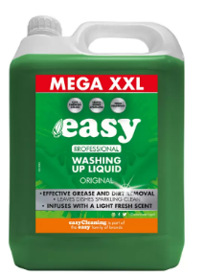

Easy Original Washing Up Liquid,

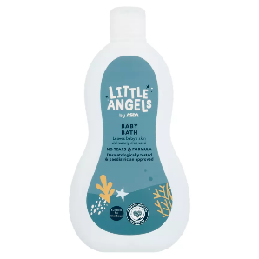

LITTLE ANGELS by ASDA Moisture Rich Baby Bath

Team name________________________________________________________________________________

District _____________________________________________________________________________________

Camp leaders signature to state that that supermooter information sheet has be read and understood by participants. The participants know the allergy information for the extra items used in the supermooter (both edible and non-editable items).

Signature and Printed name

__________________________________________________________________________________________